Closed Zigzag Shapes
# Source: AI Source: Provided by: [Data Path: Persons Table -> ID Column: 1, Name_En Column: Motasem Essam] -> From: [ChatGPT] on [7/25/2026]
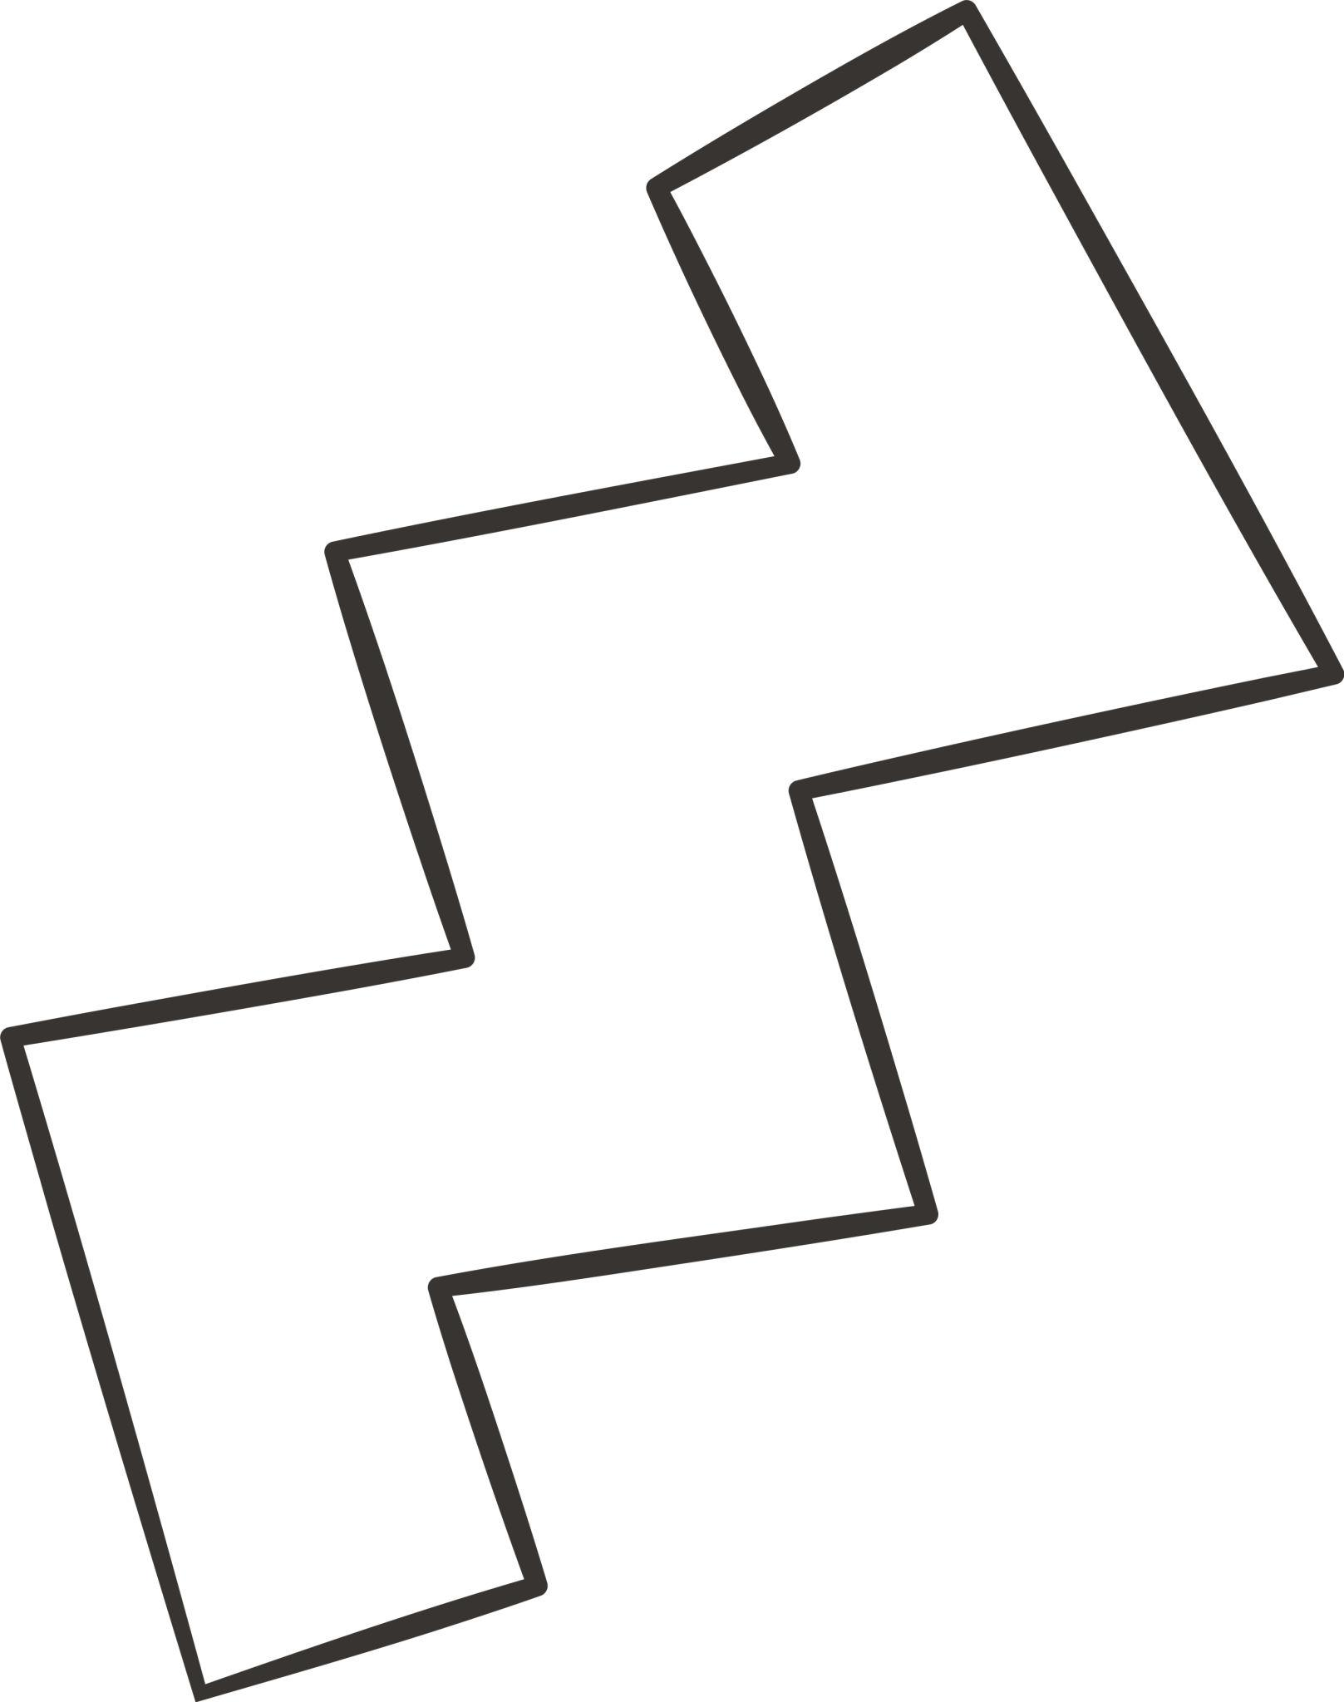
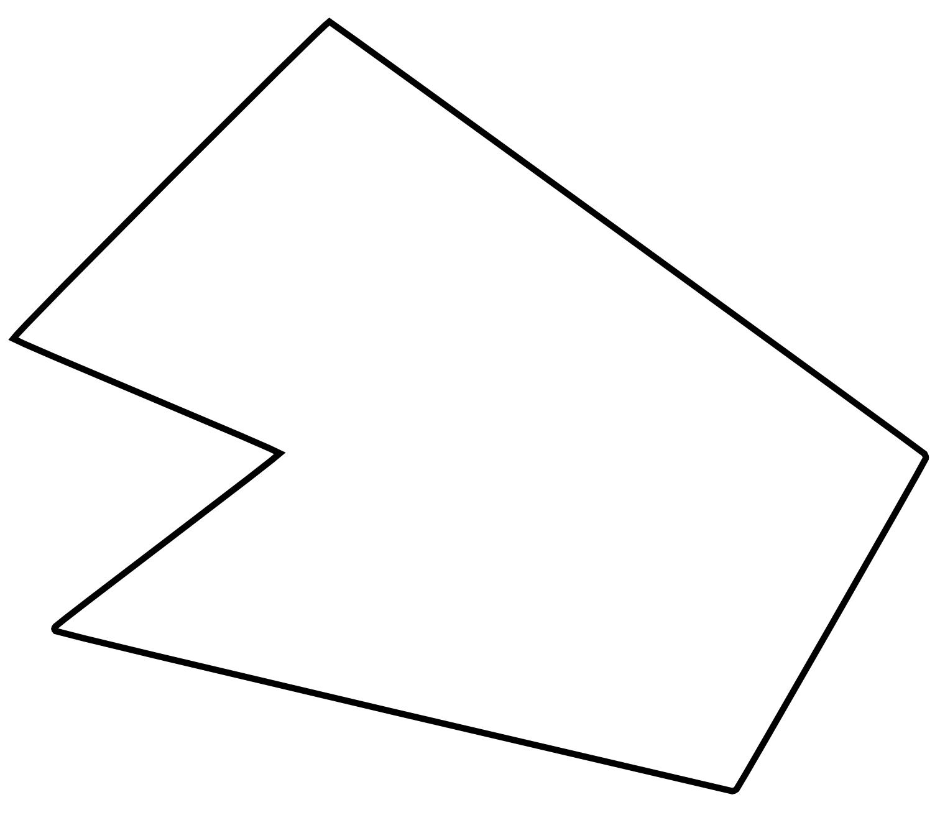
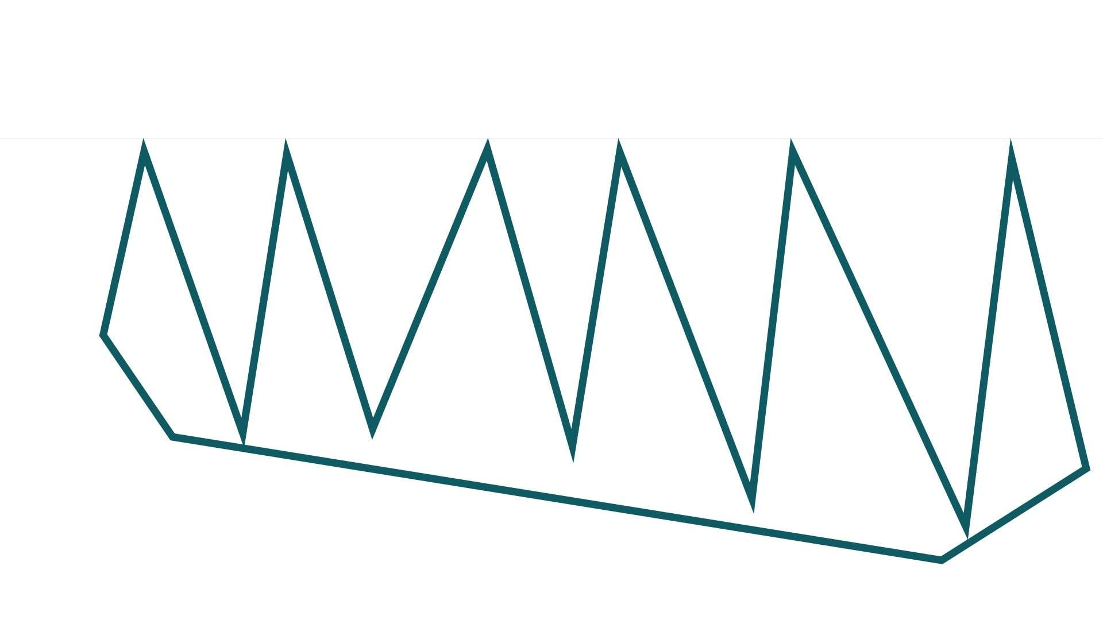
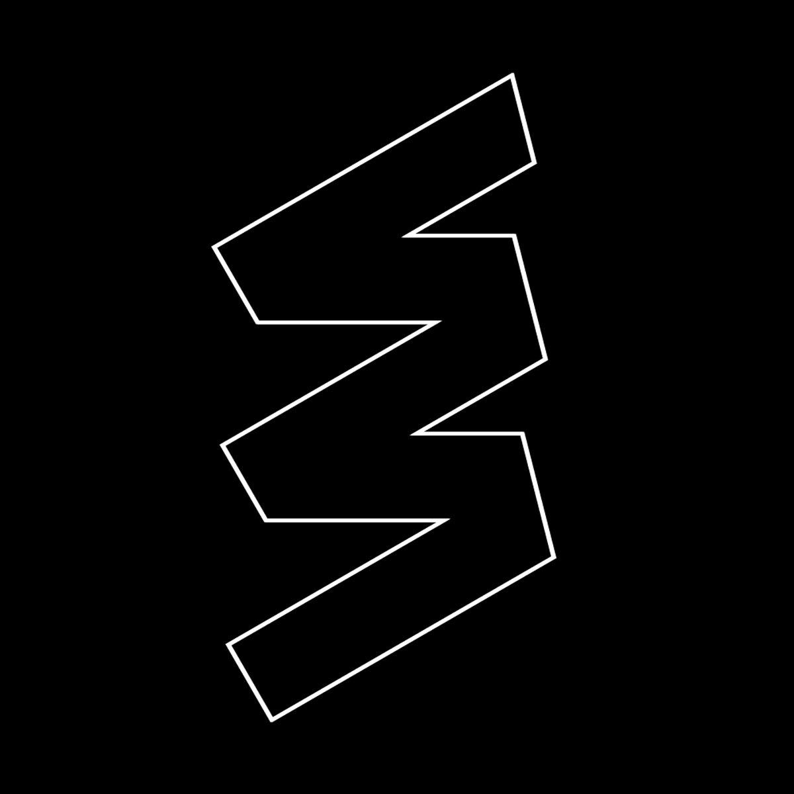

Definition
# Source: AI Source: Provided by: [Data Path: Persons Table -> ID Column: 1, Name_En Column: Motasem Essam] -> From: [ChatGPT] on [7/25/2026]
A Closed Zigzag Shape is a zigzag-shaped form whose connected line segments return to the starting point, creating a closed boundary.
Unlike an open zigzag, a closed zigzag has no distinct endpoints and encloses a region.
When a closed zigzag is composed entirely of straight line segments, it forms a polygon, usually a concave polygon because of its inward zigzagging boundary.

Fundamental Concept
# Source: AI Source: Provided by: [Data Path: Persons Table -> ID Column: 1, Name_En Column: Motasem Essam] -> From: [ChatGPT] on [7/25/2026]
A closed zigzag is created by connecting a sequence of line segments end-to-end until the final segment connects back to the first point.
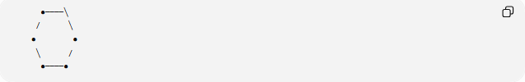
●────╲
/ ╲
● ●
╲ /
●────●
The general structure is:
$$P_{1}→P_{2}→P_{3}→⋯→P_{n}→P_{1}$$
The final point connects back to $P_{1}$, making the path closed.

Main Characteristics
# Source: AI Source: Provided by: [Data Path: Persons Table -> ID Column: 1, Name_En Column: Motasem Essam] -> From: [ChatGPT] on [7/25/2026]
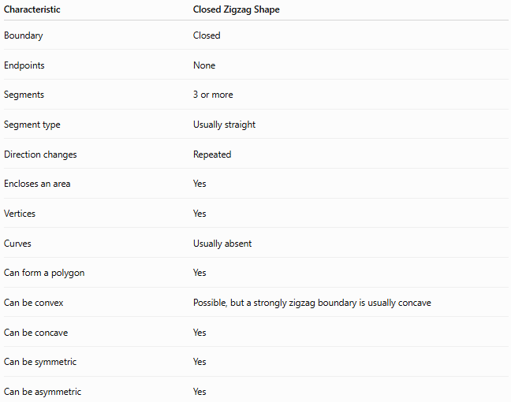
Characteristic | Closed Zigzag Shape
Boundary | Closed
Endpoints | None
Segments | 3 or more
Segment type | Usually straight
Direction changes | Repeated
Encloses an area | Yes
Vertices | Yes
Curves | Usually absent
Can form a polygon | Yes
Can be convex | Possible, but a strongly zigzag boundary is usually concave
Can be concave | Yes
Can be symmetric | Yes
Can be asymmetric | Yes

Basic Structure
# Source: AI Source: Provided by: [Data Path: Persons Table -> ID Column: 1, Name_En Column: Motasem Essam] -> From: [ChatGPT] on [7/25/2026]
A closed zigzag consists of vertices connected in sequence:
P₁ → P₂ → P₃ → P₄ → P₅ → P₁
The segments are:
$$\overset{‾}{P_{1}P_{2}}, \overset{‾}{P_{2}P_{3}}, \overset{‾}{P_{3}P_{4}}, \overset{‾}{P_{4}P_{5}}, \overset{‾}{P_{5}P_{1}}$$
Because the final segment returns to $P_{1}$, the boundary is closed.

Types of Closed Zigzag Shapes
# Source: AI Source: Provided by: [Data Path: Persons Table -> ID Column: 1, Name_En Column: Motasem Essam] -> From: [ChatGPT] on [7/25/2026]
Closed zigzag shapes can be classified according to their geometric pattern:
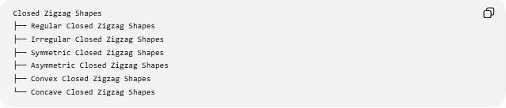
Closed Zigzag Shapes
├── Regular Closed Zigzag Shapes
├── Irregular Closed Zigzag Shapes
├── Symmetric Closed Zigzag Shapes
├── Asymmetric Closed Zigzag Shapes
├── Convex Closed Zigzag Shapes
└── Concave Closed Zigzag Shapes

1-Regular Closed Zigzag Shapes
# Source: AI Source: Provided by: [Data Path: Persons Table -> ID Column: 1, Name_En Column: Motasem Essam] -> From: [ChatGPT] on [7/25/2026]
A regular closed zigzag follows a repeated and consistent geometric pattern.
Its segments and angles may follow a systematic relationship.
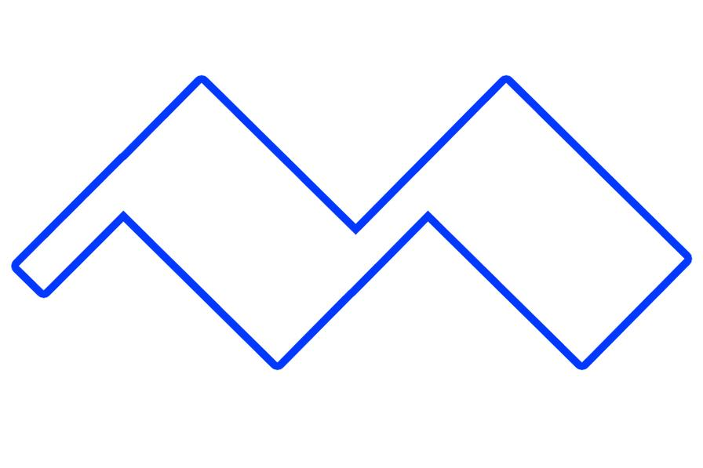
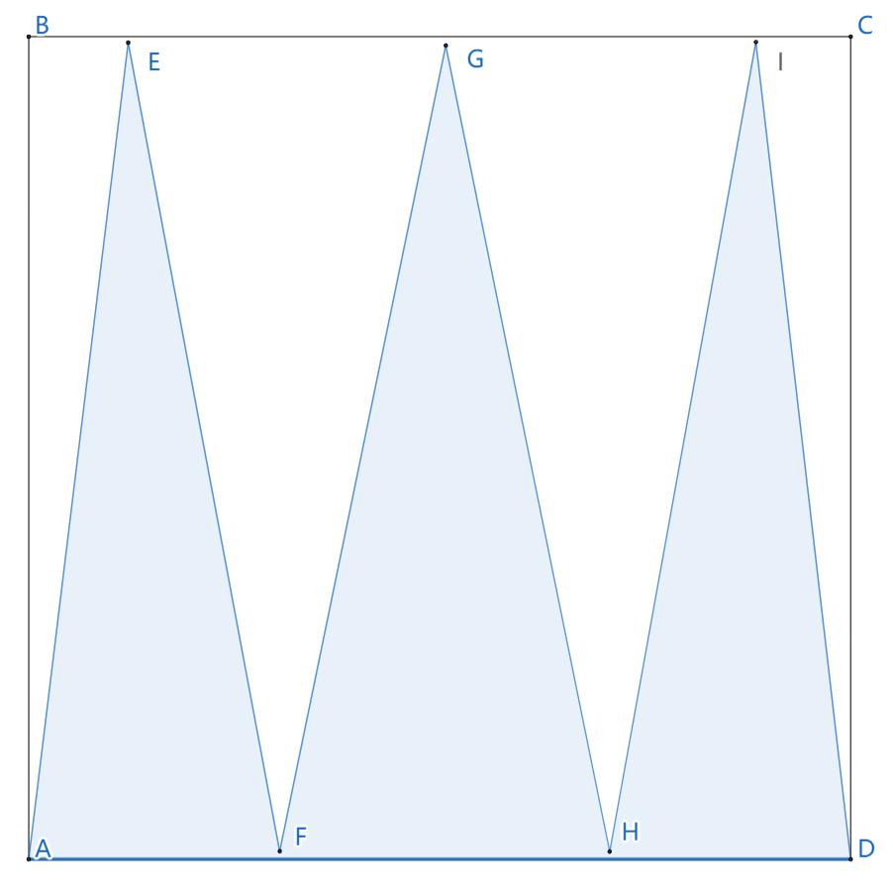

2-Irregular Closed Zigzag Shapes
# Source: AI Source: Provided by: [Data Path: Persons Table -> ID Column: 1, Name_En Column: Motasem Essam] -> From: [ChatGPT] on [7/25/2026]
An irregular closed zigzag does not maintain a uniform pattern.
Its:
- segment lengths may differ,
- angles may differ,
- zigzag depths may vary.
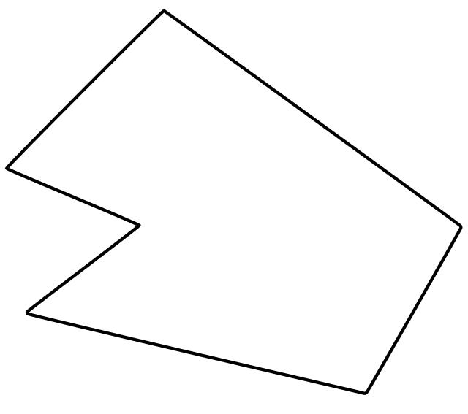
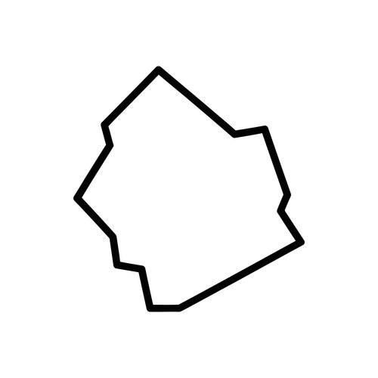
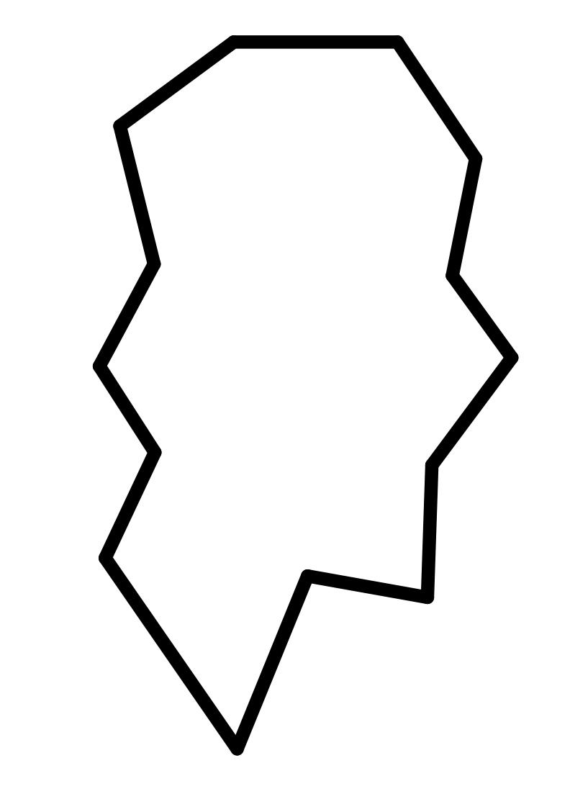
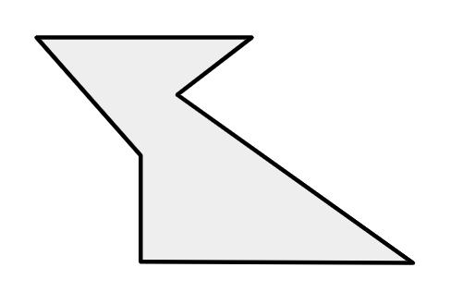
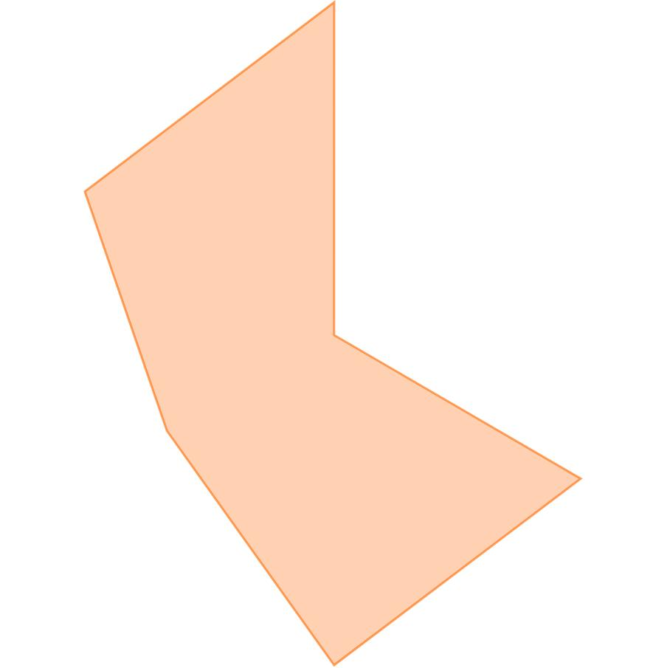

3-Symmetric Closed Zigzag Shapes
# Source: AI Source: Provided by: [Data Path: Persons Table -> ID Column: 1, Name_En Column: Motasem Essam] -> From: [ChatGPT] on [7/25/2026]
A symmetric closed zigzag has one or more symmetry transformations that map the shape onto itself.
For example, it may have reflection symmetry or rotational symmetry.

4-Asymmetric Closed Zigzag Shapes
# Source: AI Source: Provided by: [Data Path: Persons Table -> ID Column: 1, Name_En Column: Motasem Essam] -> From: [ChatGPT] on [7/25/2026]
An asymmetric closed zigzag has no symmetry under the transformation being considered.

5-Convex Closed Zigzag Shapes
# Source: AI Source: Provided by: [Data Path: Persons Table -> ID Column: 1, Name_En Column: Motasem Essam] -> From: [ChatGPT] on [7/25/2026]
A closed polygon is convex when every interior angle is less than ${180}^{∘}$and no part of the boundary bends inward.
However, a strongly zigzagging boundary with repeated inward and outward turns is generally not convex.
Thus, the term closed zigzag is more commonly associated with concave or angular polygons than with convex polygons.

6-Concave Closed Zigzag Shapes
# Source: AI Source: Provided by: [Data Path: Persons Table -> ID Column: 1, Name_En Column: Motasem Essam] -> From: [ChatGPT] on [7/25/2026]
A concave closed zigzag contains one or more inward indentations.
At least one interior angle is greater than ${180}^{∘}$.
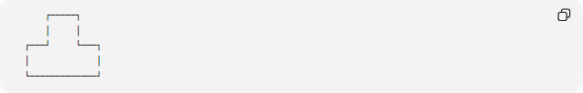
┌─────┐
│ │
┌───┘ └───┐
│ │
└─────────────┘
This is a common form of a closed zigzag polygon.

Mathematical Properties
# Source: AI Source: Provided by: [Data Path: Persons Table -> ID Column: 1, Name_En Column: Motasem Essam] -> From: [ChatGPT] on [7/25/2026]
Number of Vertices and Sides
For a simple closed polygon, the number of vertices equals the number of sides:
$$\boxed{V=n}$$
where $n$is the number of sides.
Interior Angle Sum
For a simple closed $n$-sided polygon:
$$\boxed{S=\left(n-2\right){180}^{∘}}$$
For example, a closed zigzag hexagon has:
$$\left(6-2\right){180}^{∘}={720}^{∘}$$
Area
Because the boundary is closed, the shape encloses an area.
For simple rectilinear zigzag polygons, the area can often be calculated by:
- dividing the shape into rectangles or triangles,
- adding and subtracting component areas,
- or using a coordinate-based area formula.
Perimeter
The perimeter is the sum of all boundary-segment lengths:
$$\boxed{P=l_{1}+l_{2}+⋯+l_{n}}$$

Closed Zigzag Shape vs. Open Zigzag Shape
# Source: AI Source: Provided by: [Data Path: Persons Table -> ID Column: 1, Name_En Column: Motasem Essam] -> From: [ChatGPT] on [7/25/2026]
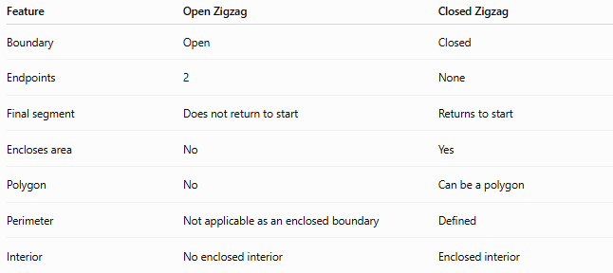
Feature | Open Zigzag | Closed Zigzag
Boundary | Open | Closed
Endpoints | 2 | None
Final segment | Does not return to start | Returns to start
Encloses area | No | Yes
Polygon | No | Can be a polygon
Perimeter | Not applicable as an enclosed boundary | Defined
Interior | No enclosed interior | Enclosed interior
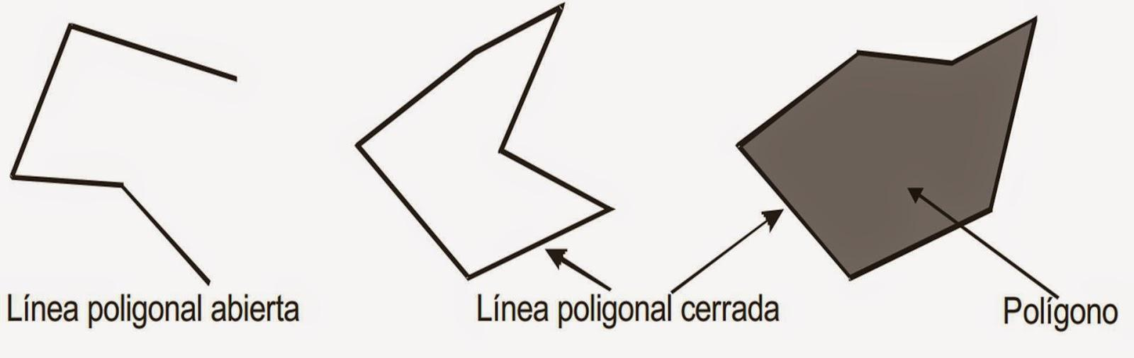
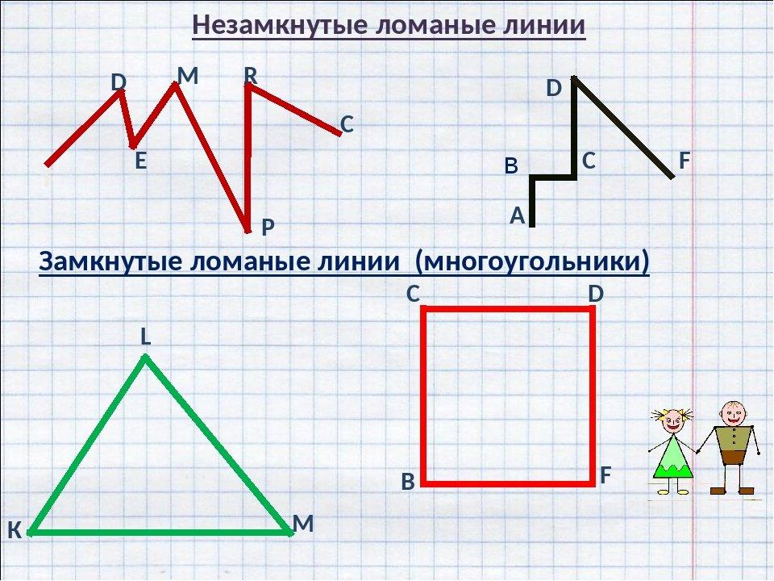
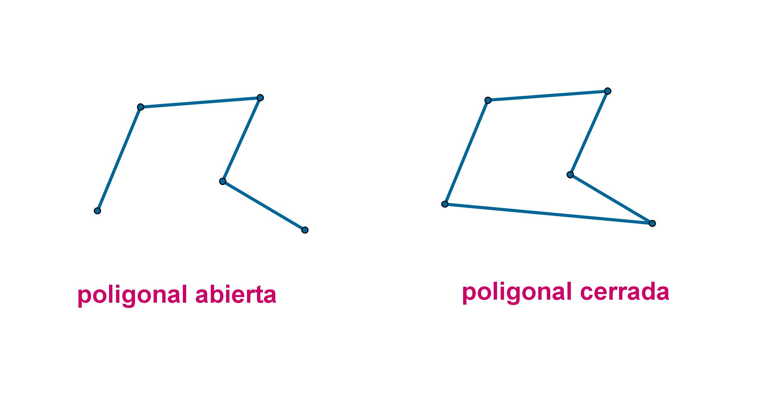

Closed Zigzag Shape vs. Regular Polygon
# Source: AI Source: Provided by: [Data Path: Persons Table -> ID Column: 1, Name_En Column: Motasem Essam] -> From: [ChatGPT] on [7/25/2026]
A regular polygon has all sides and all interior angles equal.
A closed zigzag does not necessarily satisfy these conditions.
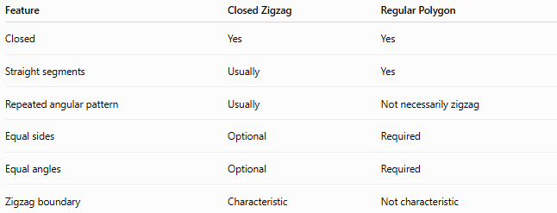
Feature | Closed Zigzag | Regular Polygon
Closed | Yes | Yes
Straight segments | Usually | Yes
Repeated angular pattern | Usually | Not necessarily zigzag
Equal sides | Optional | Required
Equal angles | Optional | Required
Zigzag boundary | Characteristic | Not characteristic
Therefore, closed and zigzag describe different properties from regularity.

Examples

Example 1 – Closed Zigzag Polygon
# Source: AI Source: Provided by: [Data Path: Persons Table -> ID Column: 1, Name_En Column: Motasem Essam] -> From: [ChatGPT] on [7/25/2026]
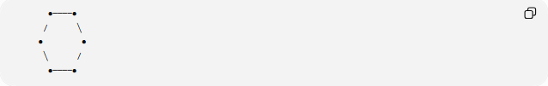
●────●
/ ╲
● ●
╲ /
●────●
The boundary returns to its starting point, so it is closed.

Example 2 – Concave Closed Zigzag
# Source: AI Source: Provided by: [Data Path: Persons Table -> ID Column: 1, Name_En Column: Motasem Essam] -> From: [ChatGPT] on [7/25/2026]
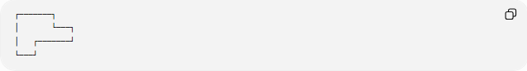
┌───────┐
│ └───┐
│ ┌───────┘
└───┘
The inward indentation makes the polygon concave.
Example 3 – Symmetric Closed Zigzag
A closed zigzag may be arranged so that one half is the mirror image of the other.

Classification Summary
# Source: AI Source: Provided by: [Data Path: Persons Table -> ID Column: 1, Name_En Column: Motasem Essam] -> From: [ChatGPT] on [7/25/2026]
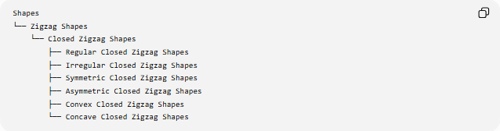
Shapes
└── Zigzag Shapes
└── Closed Zigzag Shapes
├── Regular Closed Zigzag Shapes
├── Irregular Closed Zigzag Shapes
├── Symmetric Closed Zigzag Shapes
├── Asymmetric Closed Zigzag Shapes
├── Convex Closed Zigzag Shapes
└── Concave Closed Zigzag Shapes

Key Points
# Source: AI Source: Provided by: [Data Path: Persons Table -> ID Column: 1, Name_En Column: Motasem Essam] -> From: [ChatGPT] on [7/25/2026]
- A Closed Zigzag Shape has a boundary that returns to its starting point.
- It has no separate endpoints.
- It encloses an area.
- When made entirely from straight segments, it forms a polygon.
- Closed zigzag polygons are commonly concave because of their inward indentations.
- The perimeter is the sum of all boundary-segment lengths.
- A simple $n$-sided closed zigzag polygon has an interior-angle sum of:
$$\boxed{\left(n-2\right){180}^{∘}}$$
- Closed zigzags can also be classified as regular/irregular and symmetric/asymmetric.

Conclusion
# Source: AI Source: Provided by: [Data Path: Persons Table -> ID Column: 1, Name_En Column: Motasem Essam] -> From: [ChatGPT] on [7/25/2026]
A Closed Zigzag Shape is a zigzag form with a continuous closed boundary that encloses a region. When its boundary consists entirely of straight line segments, it can be treated as a polygon, with its geometric properties determined by the number, lengths, and arrangement of its sides.

